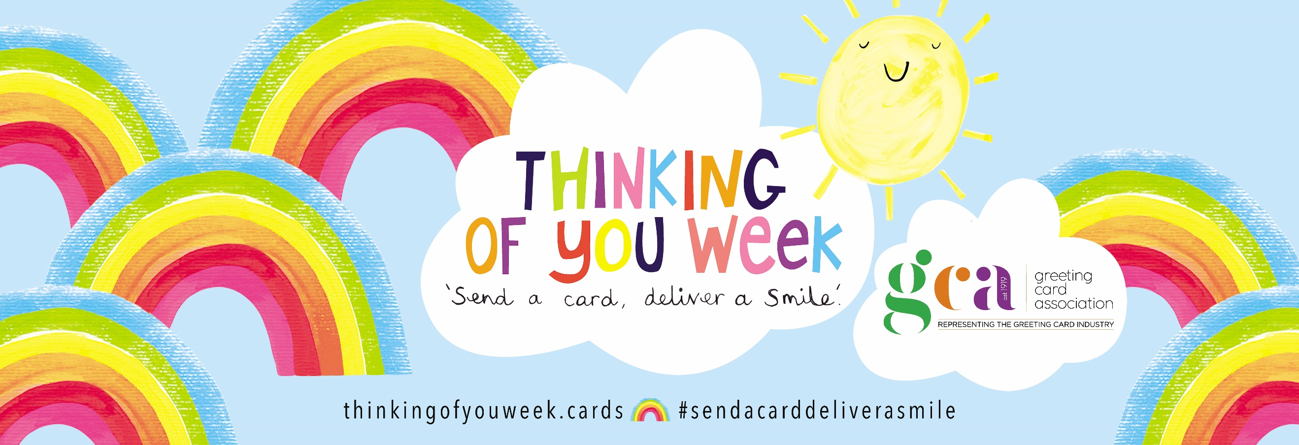

[YOUR COMPANY NAME] is taking part in Thinking of You Week, a special week from 19th – 25th September 2022 promoting sending and receiving greeting cards to create a wave of happiness around the world.

There is scientific evidence to show that receiving a handwritten card makes people feel much more special than receiving instant social media communication. This is because it takes more time, effort and emotional investment to send them – not to mention the special power of handwriting!

People around the world will be sending cards during this week to raise smiles across the miles and give everyone a positive boost.

Events will be taking place across the country and we’re celebrating the week in [YOUR TOWN] by [SUMMARY OF YOUR EVENT OR INITIATIVE.]

We would be delighted if you would join us!

[YOUR EVENT NAME]

[TIME/DATE]

[PLACE]

[WHAT YOU’LL BE DOING IN MORE DETAIL, 50-100 words]

Further information:

[YOUR CONTACT DETAILS: NAME, COMPANY, PHONE NUMBER, EMAIL, WEBSITE,
FACEBOOK PAGE]

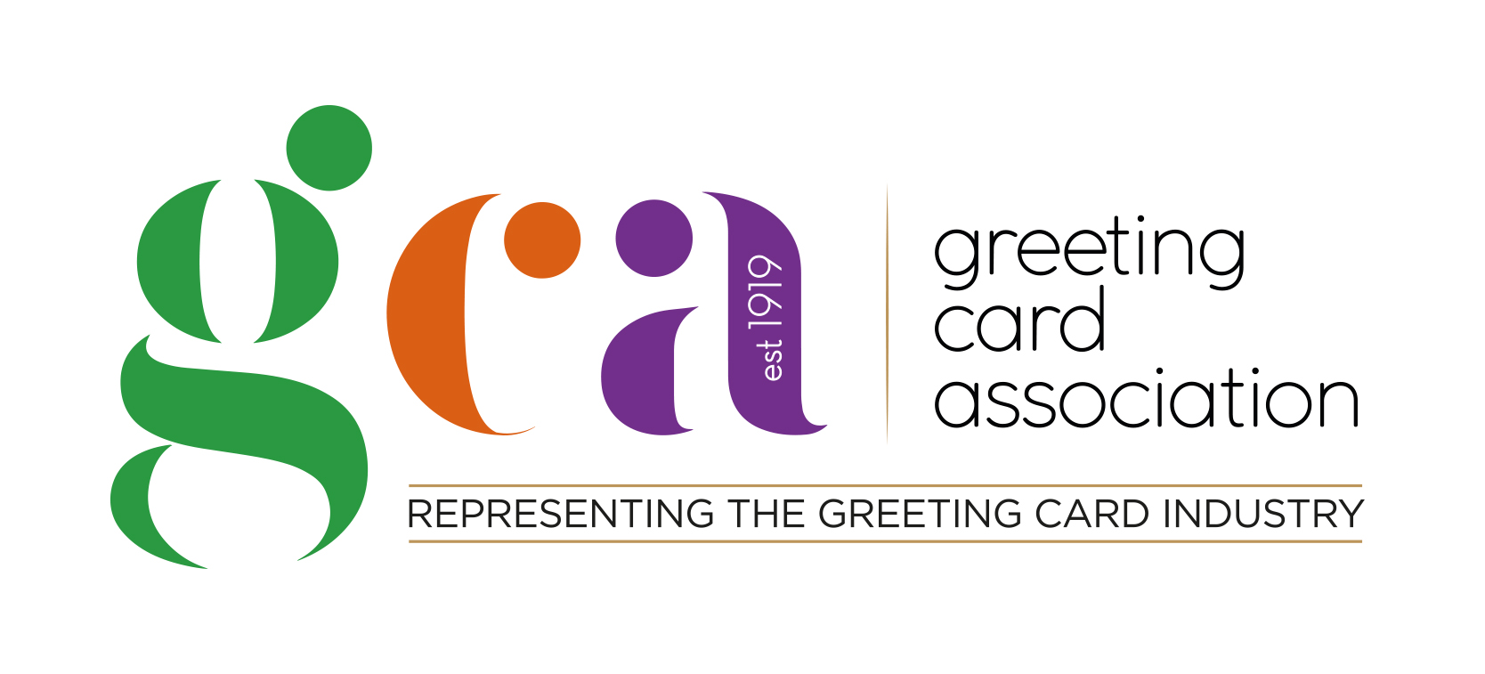
Further information about this campaign can also be found at thinkingofyouweek.cards

